P-RheologyNet: an improvement of RheologyNet

## Abstract:

Furthermore, we combined PINN with the method of residual-based adaptive refinement, a method for improving the distribution of training points adaptively during training, to further improve the performance of PINN.

[14,15] show that a properly-designed non-uniform training point weighting can improve the accuracy.

[14] Y. Gu, H. Yang, C. Zhou, Selectnet: Self-paced learning for high-dimensional partial differential equations, 2020, arXiv preprint arXi v:2001.04860. [15] L. McClenny, U. Braga-Neto, Self-adaptive physics-informed neural networks using a soft attention mechanism, 2020, arXiv preprint arXiv:2009.04544

## Keywords: Physics-informed neural network, deep learning, rheology

## 1. Introduction:

## 2. Method:

P-RheologyNet vs RheologyNet

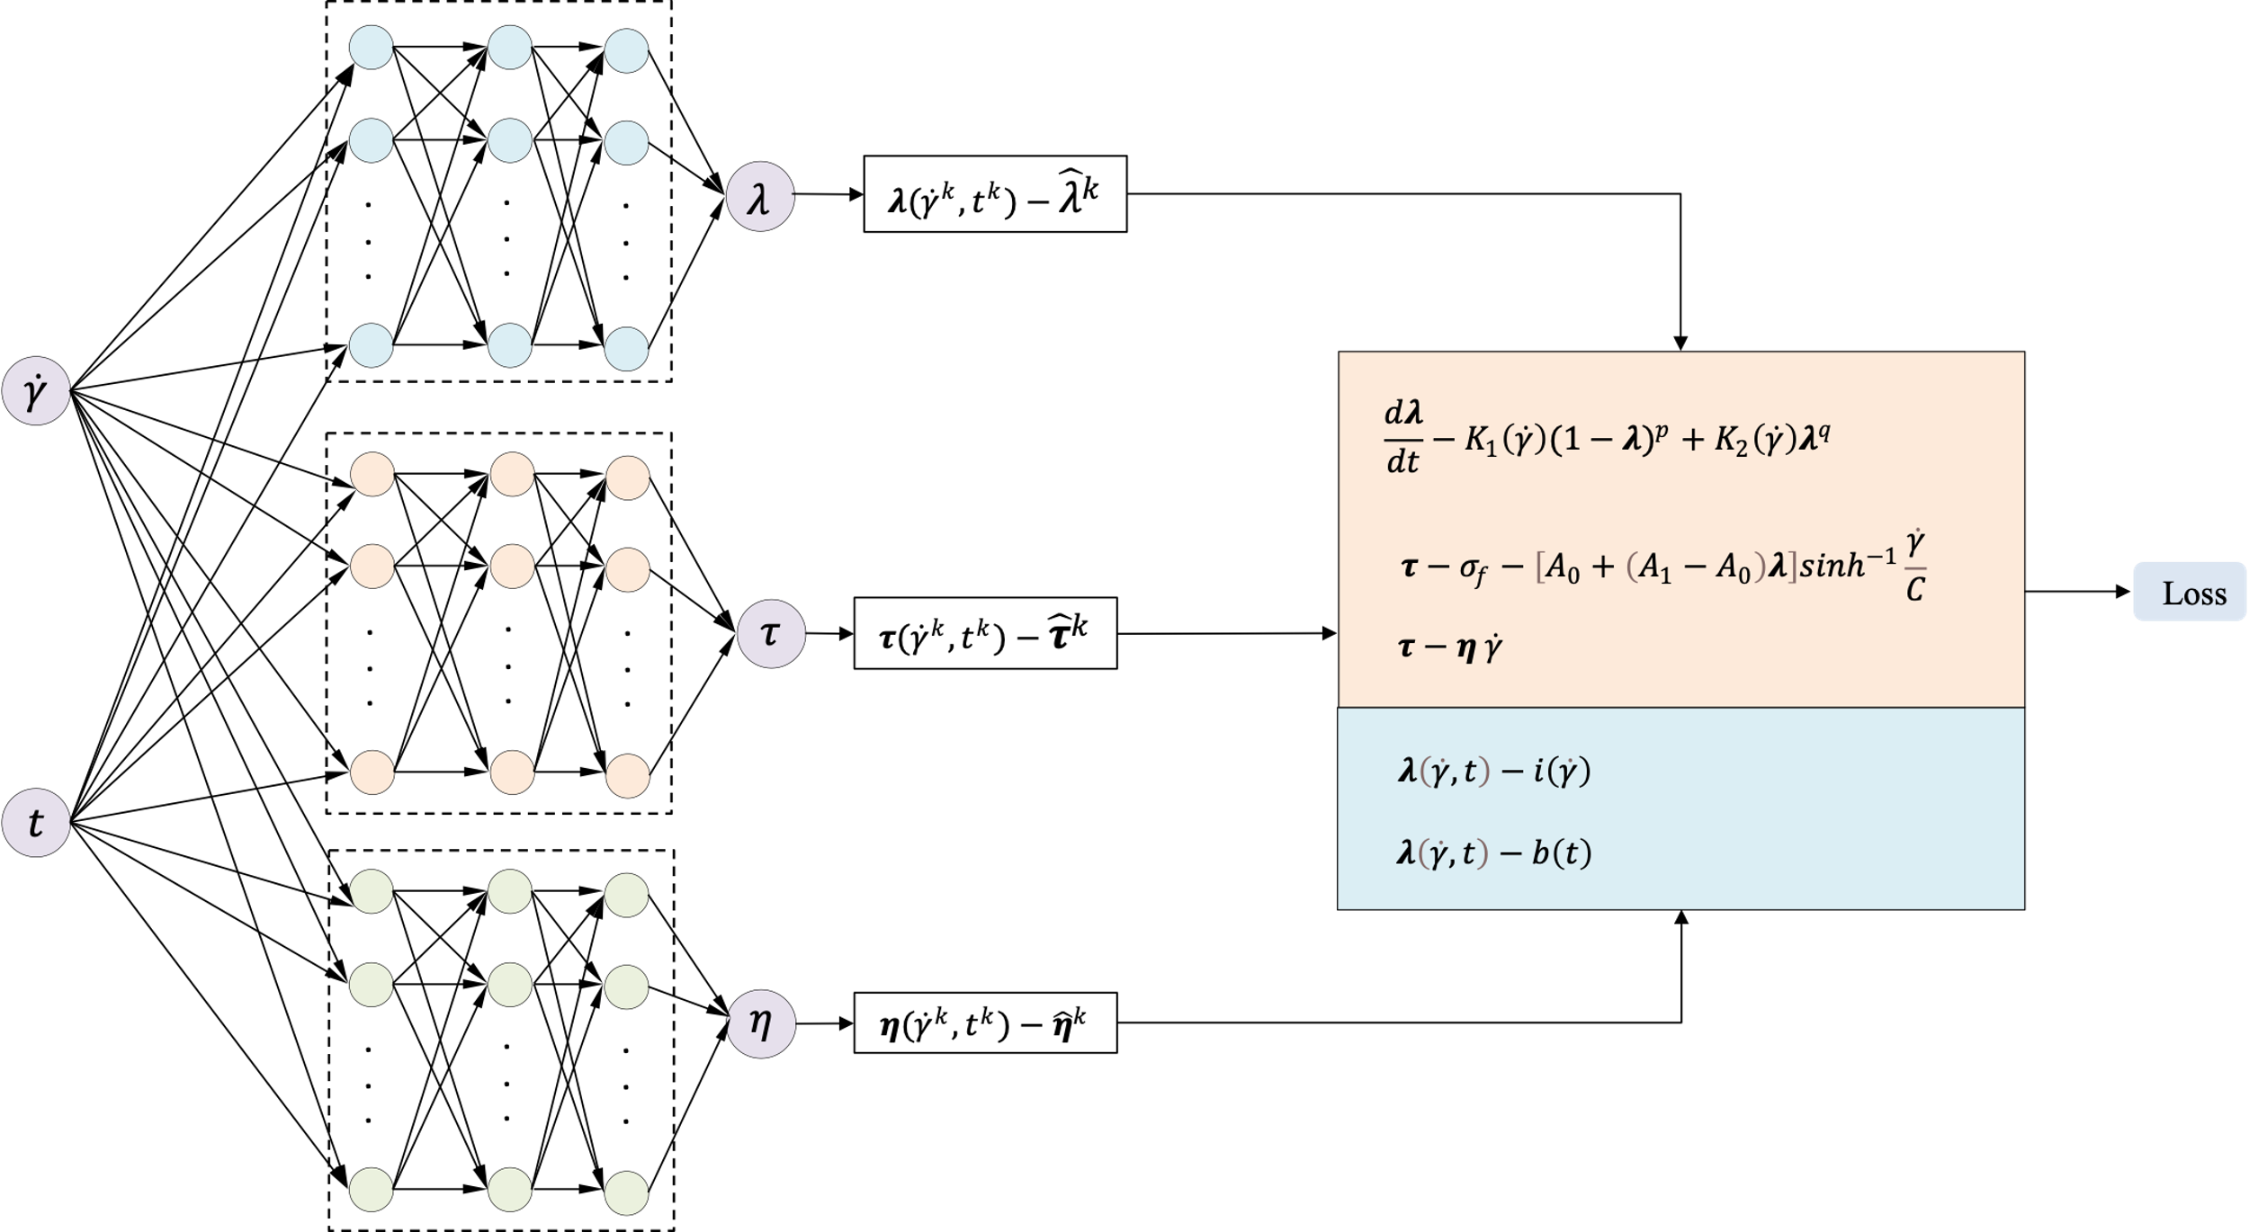

Figure 1. The structure of the parallel rheology-informed neural network.

Compared with RheologyNet, advantages:

The proposed architecture consists of three separate networks using the same inputs but different outputs. Each sub-network contains 3 layers and each layer contains 50 nodes. The training of the P-RheologyNet is carried out using a learning rate of 0.001 and the hyperbolic tangent function (Tanh) is used as the activation function. Model was trained by minimizing the loss function via Adam optimization for 50,000 epochs. 4,500 training points, including 3000 points in domain and 1500 points in boundary, were distributed across the computational domain using a pseudo distribution.

MSE compare,

Time

**RAR-P-RheologyNet**

RAR stands for Residual-Based Adaptive Refinement (RAR). For certain PDEs that exhibit solutions with steep gradients, more points need to be put near the sharp front to capture the discontinuity well. However, it is challenging to design a good distribution of residual points for problems whose solution is unknown. A RAR method is used to improve the distribution of residual points during the training process. It is similar idea to the FEM when we want to refine some delicate part in the mesh.

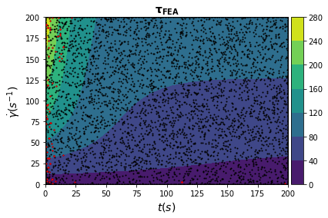

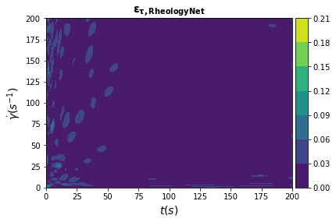 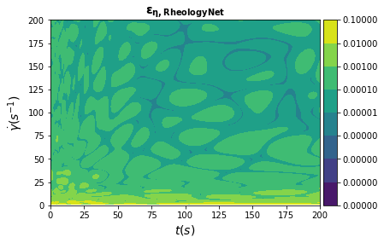

tau-mse-pinn 0.00019596412056360334

eta-mse-pinn 3.846471279573465e-06

Epochs

Learning rate

Points distribution

Layer-size

Optimization

## 3. Result

Rheologynet

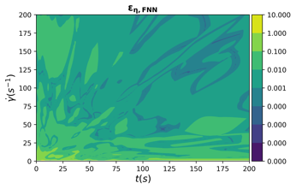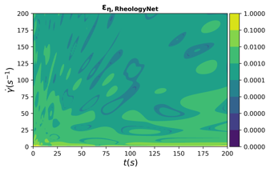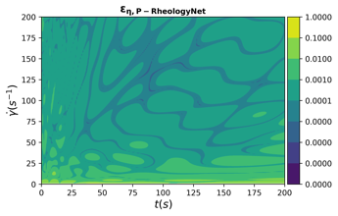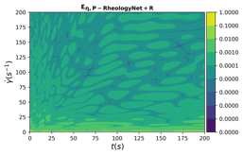

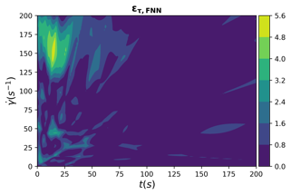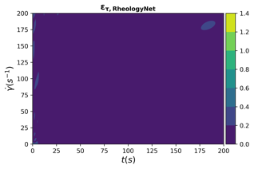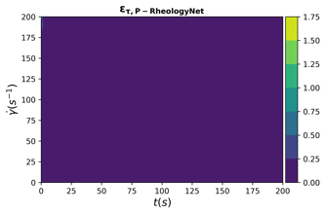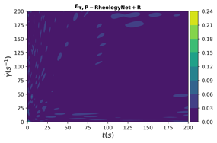

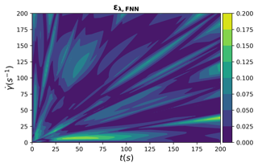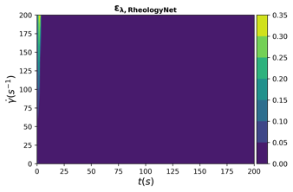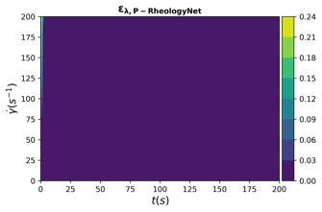

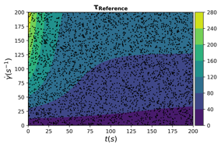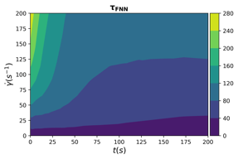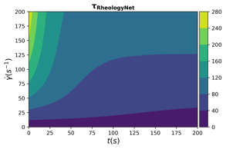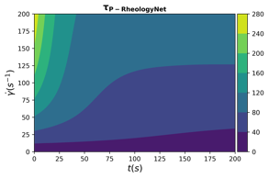

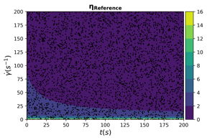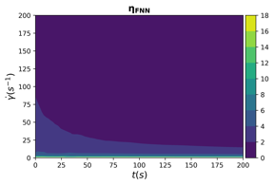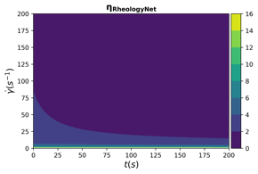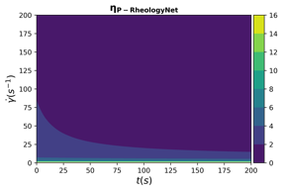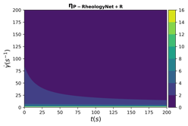

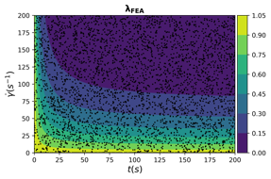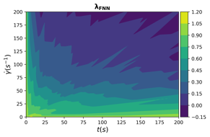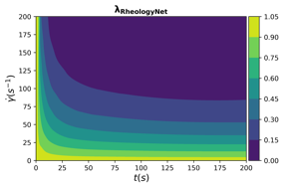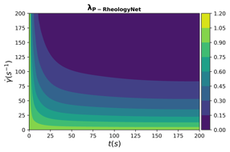

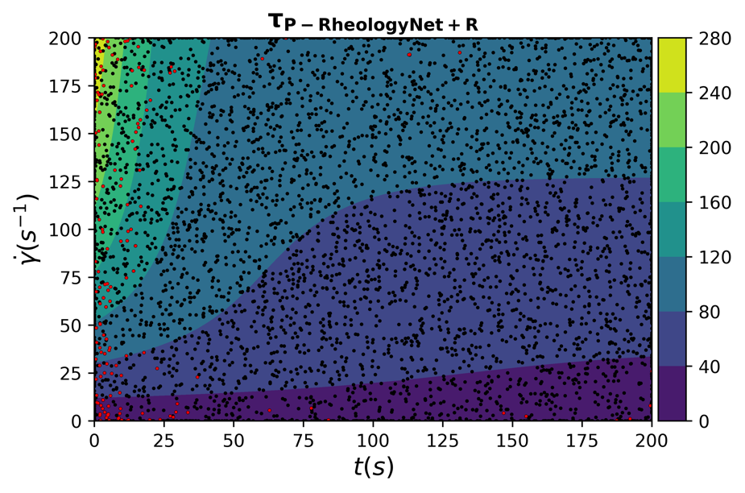

|  |  |  |  |  |
| --- | --- | --- | --- | --- |
|  | tau | eta | Reference time | lambda |
| Rheologynet1 | 0.005673621215312197 | 6.132397013355396e-05 | 0.027291059494018555 | 0.00028225730801852486 |
| 2 |  |  |  |  |
| 3 |  |  |  |  |
| Fnn1 | 0.9484676773314716 | 0.0015179348160973714 | 0.024470806121826172 | 0.0018753909670176877 |
| 2 |  |  |  |  |
| 3 |  |  |  |  |
| p-rheologynet1 | 0.0019790919919180252 | 2.9403391891013987e-05 | 0.029162883758544922 | 9.415250787850087e-05 |
| 2 |  |  |  |  |
| 3 |  |  |  |  |
| P-rheologyNet+RAR | 0.00020016934299833567 | 2.908792139897443e-06 | 4.713123083114624 |  |

## 4. Discussion

## 5. Conclusion:

## Reference: